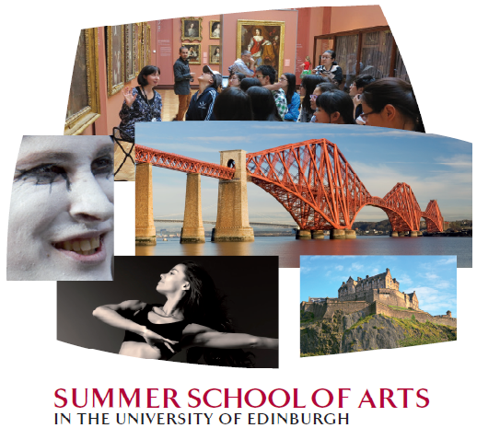

**Arts. Festivals. Edinburgh. Scotland.**

This unique Summer School of Arts programme offers a blend of academic study and cultural exploration. Organised by the Confucius Institute for Scotland in the University of Edinburgh, this summer school has attracted over 120 Chinese students in the past 6 years. It takes place during Edinburgh’s world famous festival season when the city is transformed to a stage for the world’s finest artists.

A maximum of 25 participants from Peking University and Fudan University will enjoy a number of guest lectures by distinguished speakers from the University of Edinburgh and other major cultural institutes and visit Edinburgh’s major galleries with introductions from curators. Participants will also have a chance to get to know Edinburgh with tours in the city. In addition to the study programme highlights of the visit include a 3 day 2 night tour of the Highlands, attendance at an opening event of the Edinburgh International Festival as well as tickets for the world famous Edinburgh Military Tattoo.

Summer School of Arts 2019 will run from Monday 29 July to Wednesday 7 August. Accommodation is in University of Edinburgh self-catering apartments with single bedrooms and shared bathrooms and kitchens in the first week of the programme. During the Highland trip and last 3 nights in Edinburgh, youth hostel arrangements will be made.

Final programme of 2019 will be released in June 2019. To ensure applicants to have a clear idea of the programme elements, 2018 programme is attached below for information.

The price of the summer school fee is around ££1300 per person. The fee includes all accommodation, two hosted meals, transportation, lecture programme, tickets to selected exhibitions, named shows as well as a two-day visit to the Highlands of Scotland. Applicants should also allow a per diem of £30-£50.

If you have any questions, please feel free to get in touch with us through your international programme officer.

We look forward to welcoming you in summer 2019!

