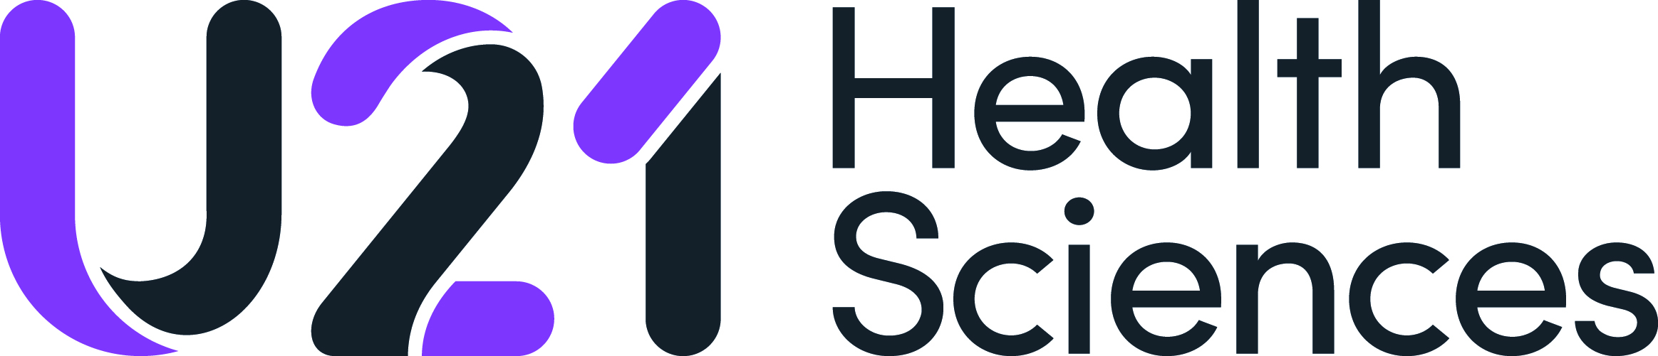

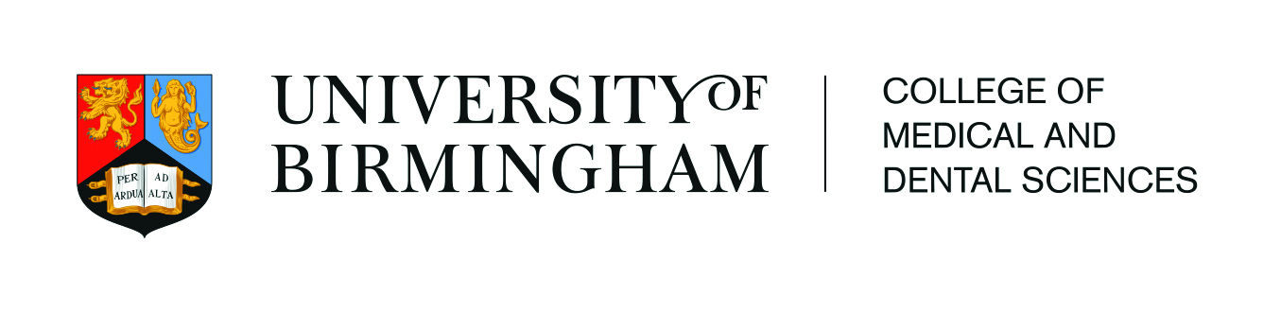

***Universitas 21* Health Sciences Summer School**

**College of Medical and Dental Sciences,**

**University of Birmingham**

**22nd July to 2nd August 2019**

**“Antimicrobial Resistance (AMR)   
and Stewardship (AMS)”**

**INFORMATION FOR INSTITUTIONS**

**QUICK FACTS**

* Full details about the U21 Health Sciences Summer School 2019 can be found at: <http://u21health.org/2019-summer-school/>
* **Dates**: 22nd July to 2nd August 2019
* **Topic**: Antimicrobial Resistance (AMR) and Stewardship (AMS)
* Cost of Programme: **$800 USD** per participating student which includes: accommodation, transport for excursions, catering (breakfast, lunch during weekdays, morning and afternoon tea during weekdays, and some dinners), cultural activities, registration, certification and materials
* Up to **45 students** can participate
* For **undergraduate students** in health sciences programmes
* Up to **5 nominated students**’ applications to be sent to Birmingham by **4th March 2019**
* Institutions informed that their students have been selected by **25th March 2019**
* One scholarship per U21 HSG institution available towards participation in the Summer School. The scholarship will be between $500 and $700 USD depending on location.

**Application Timelines**

* All student applications should be submitted to the U21 HSG Summer School institution representative, and then up to **five students** should be nominated and sent to the University of Birmingham
* The five selected completed applications from each university should be sent to Taslima Begum [u21hsgsummerschool@contacts.bham.ac.uk](mailto:u21hsgsummerschool@contacts.bham.ac.uk) by **Monday 4th March 2019**
* The names of successful applicants will be notified to home institutions no later than **Monday 25th March 2019**. The University of Birmingham will accept up to 45 students for this programme
* Students who have been selected for the Scholarship will be informed by **Friday 5 April 2019**
* Students must confirm their participation by **Friday 26th April 2019**.

**Who is this programme for?**

* Undergraduate students who have completed their first year of studies
* Students from the following programs: dentistry, pharmacy, nursing, midwifery, nutrition, medicine, public health, physiotherapy, occupational therapy, speech pathology, audiology, optometry. Please contact the U21 HSG Secretariat if you have any questions about disciplines accepted.

**U21 Health Sciences Summer School Scholarships**

**The U21 Health Sciences Group** is pleased to be able to offer one student scholarship for every institution within the network towards their participation in the Summer School. The scholarship will be between $500 and $700 USD depending on their location. Students may apply for this scholarship on the main summer school application form. Students will be informed if they have been selected for this scholarship shortly after their acceptance to the programme has been disseminated. Students will be selected for the scholarships by their U21 Health Sciences Group Summer School University Representative.

**Contact Information**

For queries regarding the Summer School programme, please contact [u21hsgsummerschool@contacts.bham.ac.uk](mailto:u21hsgsummerschool@contacts.bham.ac.uk)

For general queries please contact [u21health@gmail.com](mailto:u21health@gmail.com)