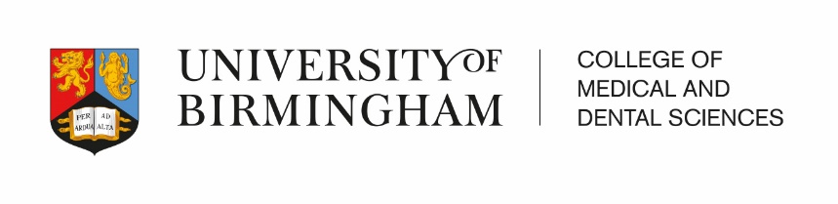




Universitas 21 Health Sciences Summer School

“Antimicrobial Resistance (AMR)
and Stewardship (AMS)”

Monday 22nd July to Friday 2nd August 2019

College of Medical and Dental Sciences
University of Birmingham
Birmingham, UK.

ACADEMIC FOCUS

Overview

The academic focus of this U21 Health Sciences Summer School will address one of the most important global issues affecting healthcare – namely Antimicrobial Resistance. Antimicrobial resistance (AMR) threatens the effective prevention and treatment of an ever-increasing range of infections caused by bacteria, parasites, viruses and fungi. AMR is an increasingly serious threat to global public health that is increasingly being given attention across all government sectors and society. Given the fact that all healthcare professionals potentially interact with patients with infections and may be involved with antimicrobial treatments, the Summer School should be applicable to all health sciences students.

The Summer School will take a multidisciplinary approach to teaching and learning, with collaborative learning groups working together throughout the meeting. The issue of AMR will be approached in a variety of ways, from a range of perspectives, including the history of infectious disease, public health issues, global infectious disease issues, antibiotic drug development, antimicrobial treatment protocols, and prudent prescribing. As well as Antimicrobial Resistance (the ‘problem’), the latter half of the meeting will aim to look at Antimicrobial Stewardship Principles (one of the ‘solutions’).

The Summer School is two weeks in length, providing an opportunity for 10 days of face-to-face learning and additional experiences. A range of learning opportunities will be offered including keynote lectures, workshops, problem-based learning, simulation, workshops, and collaborative self-directed sessions. We will also have laboratory practicals that will highlight the problems around antibiotic resistance. The keynote lectures will provide essential information on the core learning objectives of the Summer School. We will engage national and regional experts in relevant areas as lecturers, workshop facilitators and mentors.

Meeting Objectives

After the completion of the Summer School students should be able to:

- Explain how antimicrobial resistance has arisen and understand key concepts by which resistance develops in bacteria, parasites, viruses and fungi
- Appreciate the importance of Antimicrobial Resistance as a threat to healthcare sustainability
- Understand the need for coordinated action to minimize the emergence and spread of antimicrobial resistance
- Describe common infectious disease which threaten human health especially those caused by multi drug resistant organisms
- Demonstrate an understanding of antimicrobial stewardship principles and their use in practice

Organising team

The College have engaged with healthcare scientists and educators from across our programme of study and institutes of research to develop an interdisciplinary faculty.
The academic organising team will be led by:

- Professor Damian Walmsley, Director of Internationalisation and Professor of Restorative Dentistry, Institute of Clinical Sciences
- Dr Alan McNally, Institute of Microbiology and Infection
Reader in Microbial Evolutionary Genomics
Interim Director of Institute of Microbiology and Infection
- Professor Willem van Schaik, Professor of Microbiology and Infection,
Institute of Microbiology and Infection
Professor in Microbiology and Infection
- Dr Anthony Cox, Senior Lecturer in Clinical Pharmacy and Drug Safety
Programme Director MPharm
Head of Education (School of Pharmacy)
- Dr Sharon Buckley MSc PhD PGCE DipSciComm SFHEA
Institute of Clinical Sciences
Senior Lecturer in Medical Education

Many academic colleagues from around the College of Medical and Dental Sciences will be participating in the Summer School

Pedagogical approach

The Summer School learning opportunities will be focussed around blended learning approaches using a variety of educational approaches with students expected to work in learning collaborative across a number of healthcare science and professional groups. We will ensure that appropriate time is included in the programme for reflective activities and encourage active participation from all participants.

PRELIMINARY OUTLINE TIMETABLE OF MEETING

TIMETABLE Week 1 (The Problem)

Monday 22nd July 2019 | Tuesday 23rd July 2019 | Wednesday 24th July 2019 | Thursday 25th July 2019 | Friday 26th July 2019
9.30 – 12.30  Summer School Induction Day  Introduction to College of Medical and Dental Sciences  Summer School Outline | 9.30 – 12.30  History of Public Health and Infectious Diseases  Public Health | 9.30 – 12.30  Antibiotic Resistance Mechanisms  The Science behind the problem | 9.30 – 12.30  Infectious Diseases:  Travellers Infections  Pandemics  MDR diseases | 9.30 – 12.30  SEPSIS  When the bug gets the upper hand!
LUNCH | LUNCH | LUNCH | LUNCH | LUNCH
14.00 – 16.30  Antimicrobial Resistance (AMR) – A global concern to healthcare  Setting the Scene to the Problem Based Learning Scenarios  18.00 – 21.00  Welcome Meal | 14.00 – 16.30  Group work | 14.00 – 16.30  Group work | Free Time  Visit to Birmingham Museum and the Staffordshire Hoard  Visit Birmingham Library  Walk to Brindley Place, The Mailbox and finish in The Bull Ring shopping centre. | 14.00 – 16.30  Sepsis Simulations

On the weekend of Saturday 27th and Sunday 28th July 2019 there will be a social programme of events for students to participate in.

TIMETABLE Week 2 (The Solutions)

Monday 29th July 2019 | Tuesday 30th July 2019 | Wednesday 31st July 2019 | Thursday 1st August 2019 | Friday 2nd August 2019
9.30 – 12.30  Developing New Antibiotics | 9.30 – 12.30  Start Smart then Focus: Antimicrobial Stewardship in action | 9.30 – 12.30  Interprofessional aspects of AMS | 9.30 – 12.30  Innovations in Antimicrobial Resistance and Stewardship | 9.30 – 12.30  Group Presentations with International Judging panel  Antimicrobial Quiz time  Prize Giving Ceremony  Take Home messages
LUNCH | LUNCH | LUNCH | LUNCH | LUNCH AND CLOSE
14.00 – 16.30  Pharmacy Lab Activity | 14.00 – 16.30  Group work  Visit to Winterbourne Gardens | Free Time | 14.00 – 16.30  Group work  18.00 – 21.00  Farewell Meal

About the Summer School

Arriving at New Street Train Station

Birmingham is at the heart of the UK’s road and rail network and is easily accessible from other parts of the country and beyond. The University has its own train station that has a direct line to the main city centre train station, New Street Station, in just 7 minutes you can be in the heart of the city.
https://www.lonelyplanet.com/england/the-midlands/birmingham

This is Selfridges where you can shop till you drop
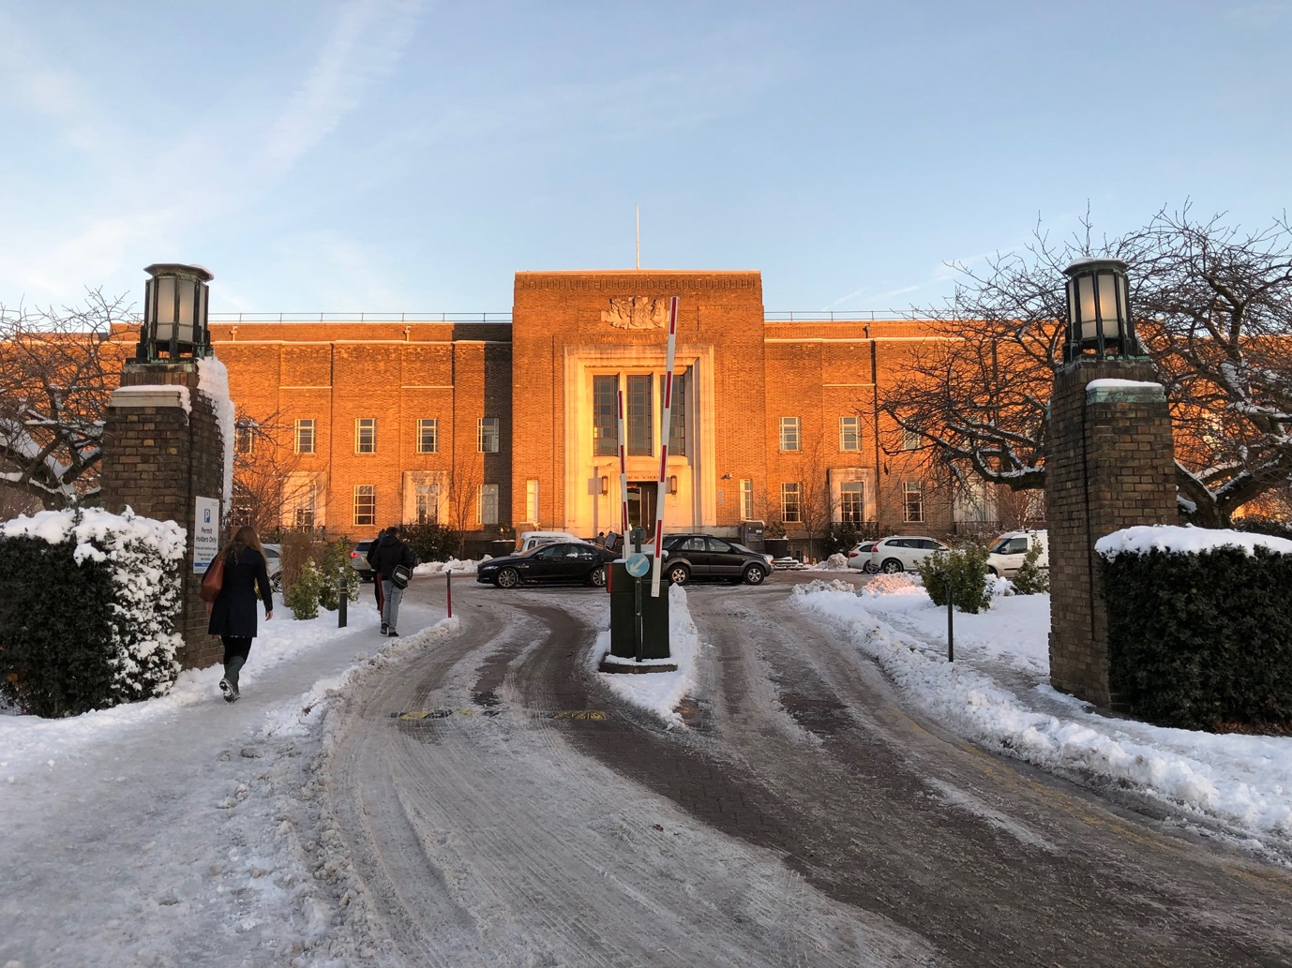
Entrance to the Medical School – this is in winter not the summer!

University of Birmingham Medical School, Birmingham, UK.
The College consists of a diverse community of academic staff, research staff, health professionals and Professional Services staff working side-by-side and in collaboration with our NHS partners, including Birmingham Health Partners (BHP), an exciting collaborative platform between the University, University Hospitals Birmingham NHS Foundation Trust and Birmingham Women's and Children's NHS Foundation Trust, to improve the lives of patients locally, nationally and globally.
Our location
The principal base of the College is part of the main campus of the University in Edgbaston, adjacent to the Queen Elizabeth Hospital Birmingham, and with a number of other key buildings both on and off campus, including the new Birmingham Dental Hospital and School of Dentistry at Pebble Mill, just a mile from the central campus. Other NHS Trust partners are also on the same campus, including Birmingham Women's Hospital and the Barberry Hospital.
Situated in the largest healthcare region in the country, with access to one of the largest and most diverse populations in Europe, the College is positioned to address major global issues and diseases affecting today’s society through our eight outstanding specialist Institutes.
https://www.birmingham.ac.uk/university/colleges/mds/about/index.aspx

Once at the Medical School, the Summer School programme will be held within our dedicated learning environment. The Wolfson Centre for Medical Education arranged over four floors, houses the spectacular Leonard Deacon Lecture theatre and has dedicated areas for registration, exhibitions, poster displays and refreshments. Summer School students will have access to our library for supporting collaborative learning activities.

The Wolfson lecture theatre and common room will house the main Summer School
The University has its own train station which is across the road to the Medical School.
There are excellent faciliites which will enable us run a successful Summer School.

Campus Accommodation

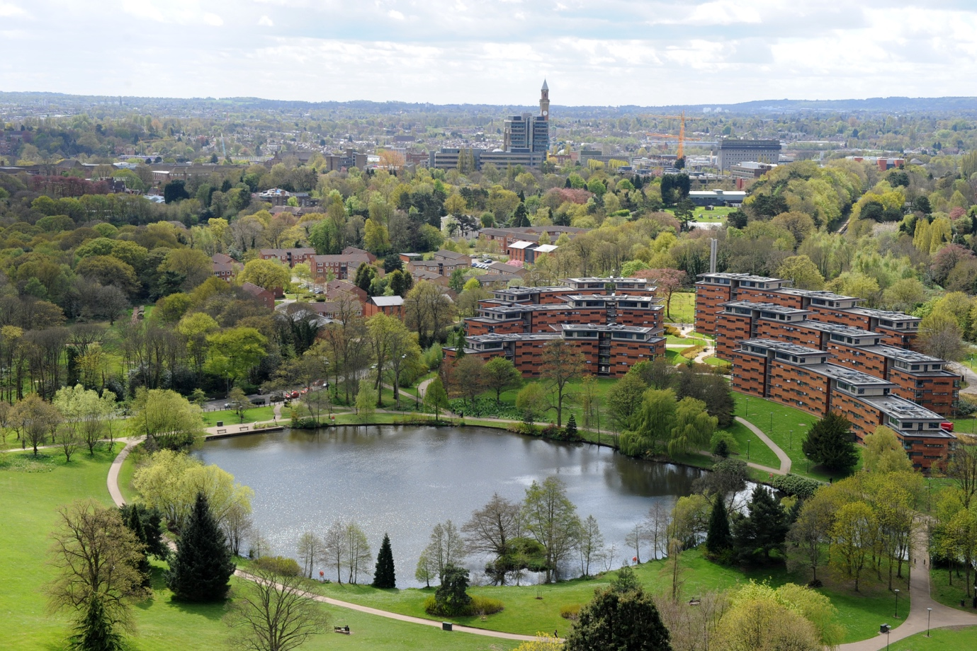
Find out about your student accommodation at the following web address
https://www.birmingham.ac.uk/study/accommodation/index.aspx

Social and Cultural Experience in Birmingham
The Cube looking over Gas Street Basin with lived in canal boats
Birmingham is a vibrant City which is situated right in the heart of England. Birmingham's location in the centre of England makes it an ideal base to explore the rest of the UK. We are only 90 minutes away from London by train and Stratford upon Avon, Warwick, Oxford, the Cotswolds and Wales are only a short journey away. It is a city of culture, combined with superb shopping, great nightlife and award-winning restaurants. Both Victoria and Chamberlain square bring together the Birmingham Museum and Art Gallery, home to some of the finest art collections in the world and the magnificent Council House and Town Hall.
So much building is taking place in Birmingham that the view is always changing
The spectacular Library of Birmingham is Europe’s largest regional library and is a flagship for the redevelopment of the city. Grab a coffee, a book and sample the extraordinary views from the roof terraces. Right at the top is a library dedicated to Shakespeare. It is well worth a visit to see the difference of old versus new architecture. The City is changing so much with all the building that this information was correct at the time of going to press.

The Barbour Institute and Winterbourne House & Garden are well worth a visit
Closer to campus is The Barber Institute of Fine Arts which exhibits works by Botticelli, Monet, Turner, Van Gogh and many more. A short walk away, set within seven acres of fine botanic gardens is Winterbourne House & Garden. A hidden gem filled with beautiful Edwardian antiques and over 6,000 species of plant life from around the world.
With more canals than Venice, why not explore and dine in Brindley Place on Broad Street. Birmingham boasts excellent shopping facilities in the Bullring shopping centre, the site of a market for more than 800 years, revamped into a state-of-the-art shopping centre, backed up with the startling Selfridges store and the marvellous Mailbox.
Meet you at the Bull for shopping and then we can go to the Mailbox
There is always the Custard Factory or St Philip’s Cathedral to explore
Looking forward to seeing you at
the U21 Health Sciences Summer School in 2019!

