# Come learn about a law program at one of the world’s top law schools designed specifically for science, technology, and engineering students

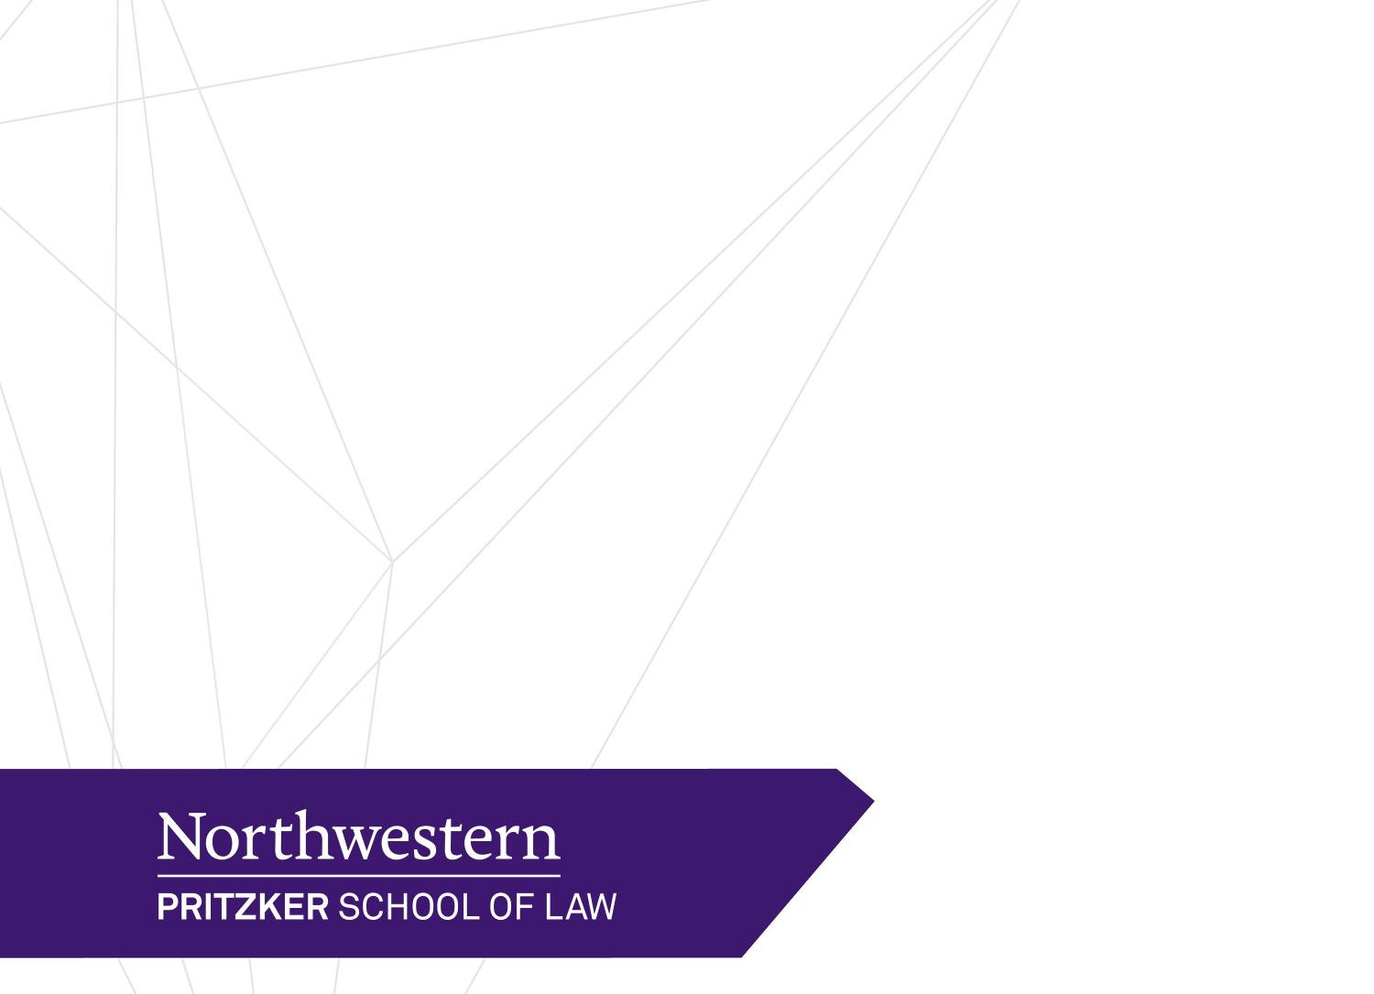

Wednesday, October 24, 2018 2:00-3:00pm

Nordic Center Building, Room 101

Contact: Evan Goldberg – [evan.goldberg@law.northwestern.edu](mailto:evan.goldberg@law.northwestern.edu)

MSL: Where STEM, Law, and Business Converge

The Master of Science in Law degree (MSL) at Northwestern Pritzker School of Law arms STEM students and professionals with the tools they need to succeed in today’s innovation economy. Graduates develop an integrative mindset that uniquely positions them to play an active role in leading industry, developing policy, advancing innovation, and commercializing ideas.

The unique MSL curriculum centers on the intersection of law, business, and technology with specific focus areas in business law and entrepreneurship, intellectual property and patent design, and regulatory analysis and strategy.

MSL students greatly benefit from studying at one of the world’s most prestigious law schools. Students have access to a highly successful alumni base, in addition to world-renowned faculty and broader Northwestern University resources. Northwestern Law is also a long-standing leader in curricular innovation, known for launching several other path-breaking programs, including one of the first entrepreneurship law centers and also the first three-year JD-MBA. MSL students truly enjoy the best of both worlds: an innovative, new law degree awarded by an established, world-class law school.