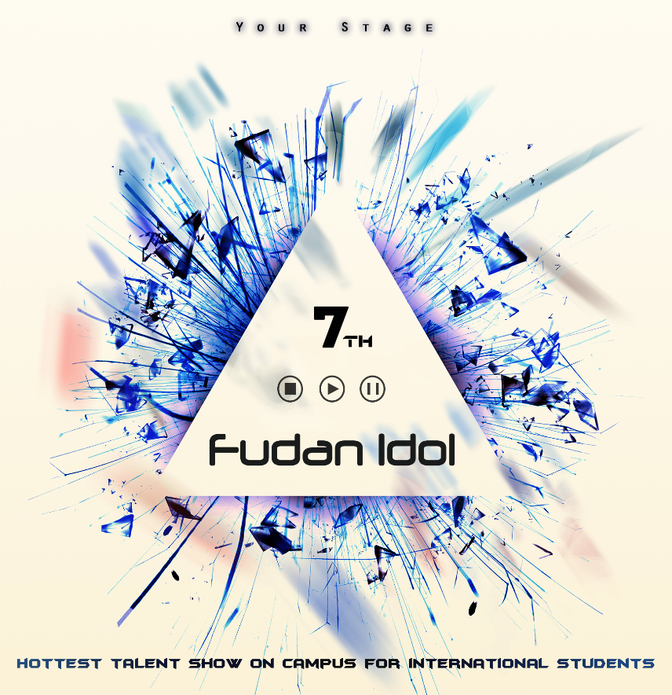\

Fudan Idol Season 7

A Fighting Song for Your Dream

*We see new stars rise on our stage*

*Those who have dreams, courage, passion, love and faith .*

*Escape from the mechanized and dull life.*

*Find and redefine themselves.*

*Will you be the next one ？*

*To be or not to be .*

*Ask yourselves and follow your heart.*

*Release the true self.*

*Pursue what you like to pursue.*

*They say we are what we are ,*

*But we don’t have to be.*

***Fudan idol is the watcher and guard***

***Of all your fever dreams***

*我们频频目睹新星冉冉升起*

*身怀梦想、勇气、激情、爱与信念的勇者*

*从机械枯燥的生活中脱逃*

*追寻并重新定义自我*

*你会是下一个吗？*

*懦弱躲避还是勇敢上前*

*扪心自问并跟随内心指引*

*解放真我*

*寻你所想*

*他们为我们妄下定义*

*但我们不必当真*

***复旦偶像将是你所有狂热梦想的***

***见证者和守护者***

**What is Fudan Idol?**

**Fudan idol** is a talent show designed for **international students** in Fudan, giving you the opportunity to show your unique talent and to prove yourselves.

Whether you are professional or amateur.

Whatever the talent you have.

**Come and show!**

Don’t miss the excellent chance prepared right for you!

To make your campus life more colorful and exciting.

To make more friends and break the small group.

To win everyone’s recognition...

**You ! are the next FUDAN IDOL!**

**复旦偶像**是一场专为**留学生**设计的综合才艺秀。给予留学生一次展示独特才能证明自己的绝佳机会。无论你专业还是业余，无论你身怀何技，**展示出来吧**！不要错过为你准备的绝佳机会。让你的校园生活精彩纷呈、激情四射，打破你的小圈子结交更多志同道合的伙伴，获得更多人的认可......

**下一个复旦偶像，就是你！**

**Anyone is welcome!**

**Singer?**

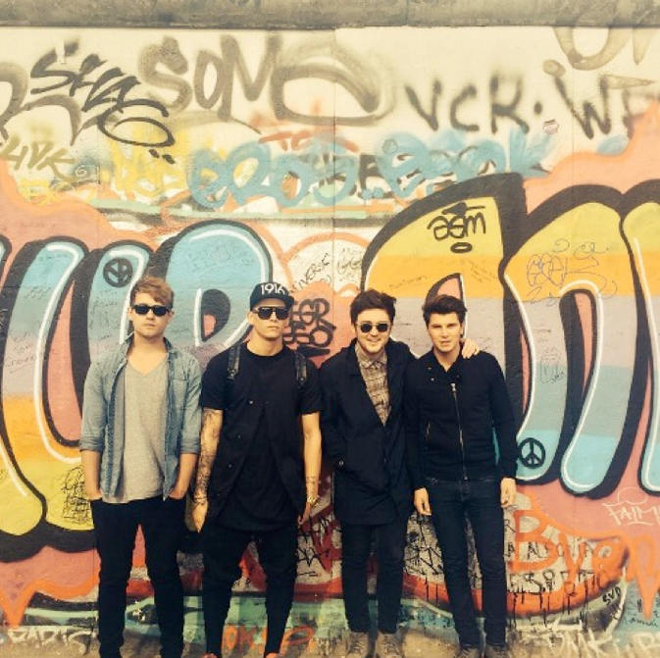

**W**anna be the Adam Lambert?

**W**anna use your Siren singing voice to capture everyone’s heart?

**W**e welcome anyone who love singing ,who wants to sing freely , who have dreams to be a singer.

想成为一下个亚当·兰伯特吗?

想用你塞壬海妖般的歌喉俘获众人吗?

我们欢迎任何一个爱好音乐，想要自由歌唱，拥有歌手梦想的青年。

**Dancer?**



**I**f you have confidence in your body , just show us your music and dancing.

**M**ove with the heartbeat and soul.

**E**very step is going to bloom with your sweat and effort.

如果你足够自信，尽管展示你的舞步

随着心跳和灵魂律动

你踩下的每一步都将绽放以汗水和辛勤浇灌的花朵。

**Band?**



**C**an’t find fans for your band?

**W**anna hold a splendid and awesome concert for your rock dream?

**W**e've built the most suitable stage for you!

找不到跟随你一起摇摆的忠实拥趸？

想要为内心的摇滚魂举办一场盛大完美的演唱会？

我们为你搭建了最适合你的舞台！

**Anyone!**



**Maybe you are talented , maybe you are not.**

**Maybe you have no experience.**

**Maybe you are one of the most ordinary people in the huge crowd.**

**But,you totally can,as long as you want to.**

**Why not find the most wonderful and brilliant part of yourselves?**

**To make the experience a piece of memory never fading away！**

**也许你生来具有天赋，抑或没有。**

**也许你从未有过相似的经验。**

**也许你也曾是行走在平庸的巨大人潮中那不起眼的一员。**

**但是，只要你想，便有实现的可能。**

**为何不去寻找自身最闪耀的光点？**

**让这段经历成为永不泛黄的回忆！**

**Know our process**

**Preliminary(初赛）**

**Date**：Nov.6th/7th/8th

**Time**: 18:30-21:00

**Address**：Student Square,1F GuangHua Building Student Square（学生广场）

**Final（决赛）**

**Date：**Dec.4th

**Address**：Wuwenzheng Hall (吴文政报告厅)

**Ways to sign up**

**A.Via Wechat(Recommend):**

“Read more”at the bottom of the page will guide you to our signing up platform! Choose "立即报名" and fill up your information.



**B.Via SMS：**

Send text including "Name+ Gender+ Nationality+ Talent+ Phone number+ Email + Wechat + Preliminary date selection (Nov.6th-8th)" to **15121175756.**

**C.Via Email：**

Send email including "Name+ Gender+ Nationality+ Talent+ Phone number+ Email + Wechat + Preliminary date selection (Nov.6th-8th)" to **fudanidol2015@163.com**.

**（from this day to Nov.2nd）**